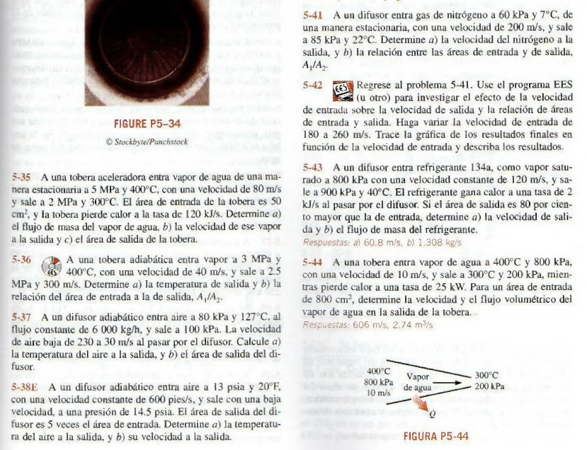
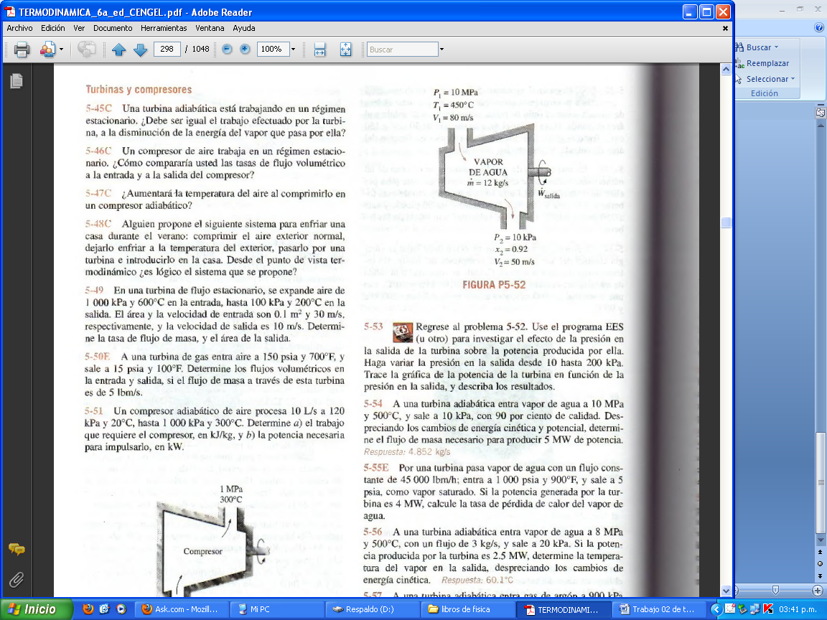
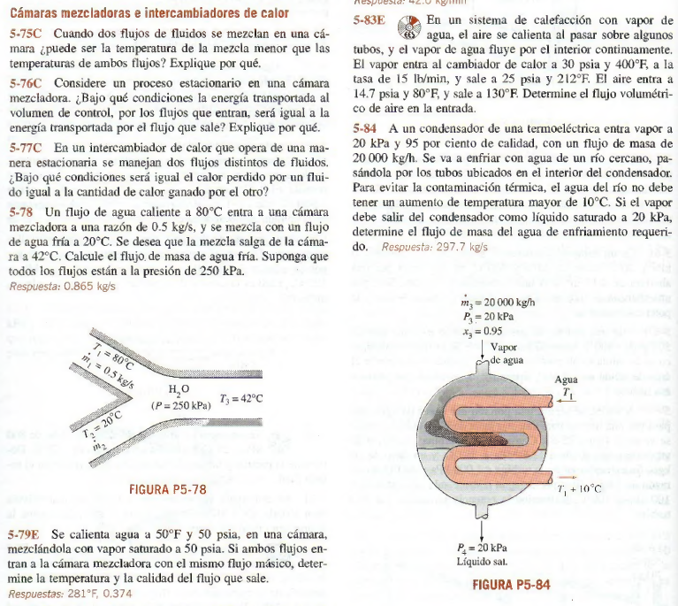
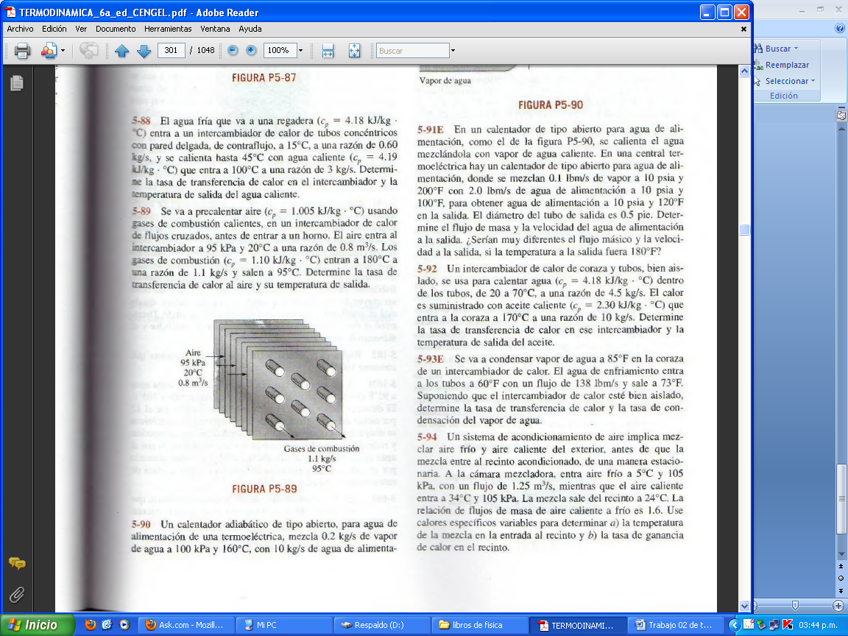

- Periche Antón 5.89 , 5.54 , 5.44
- Silva Felix 5.92 , 5.55E , 5.43
- Alverca Velasco 5.91E ,556 , 541
- Granda Pangalima 5.88, 5.49,5.37
- Jimens Guerrero 5.94, 5.50E ,5.35
- Peña Jaramillo 5.93E, 5.55E ,5.38E
- Flores Ipanaque 5.78, 5.49, 5.31
- Gomez Chiroque 5.79E, 5.46E ,5.43
- Maza Alburqueque 5.92 , 5.55E , 5.43
- Ramirz Panduro 5.94, 5.88, 5.54
- Pacherrez Sandoval 5.87 , 5.76C , 5.41
- Chero Ojeda 5.93, 5.55E,5.44

